**CDN**

We need to create Origin server in S3 Bucket.Click on create bucket and provide the name to Bucket.

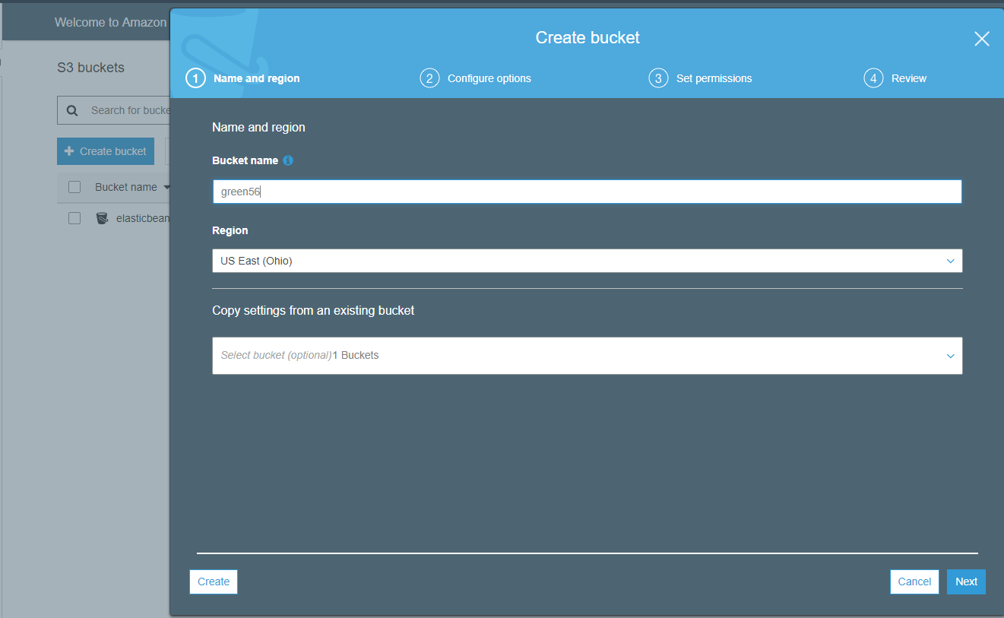

Once Bucket is created click on permission tab to make public accessibility to bucket by clicking on ACL,Public blocker

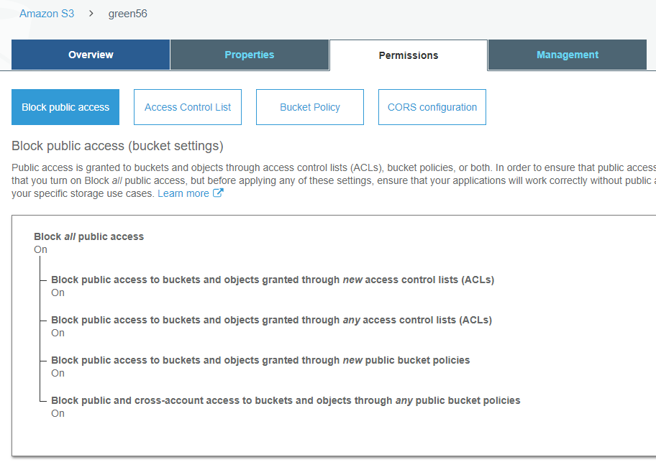

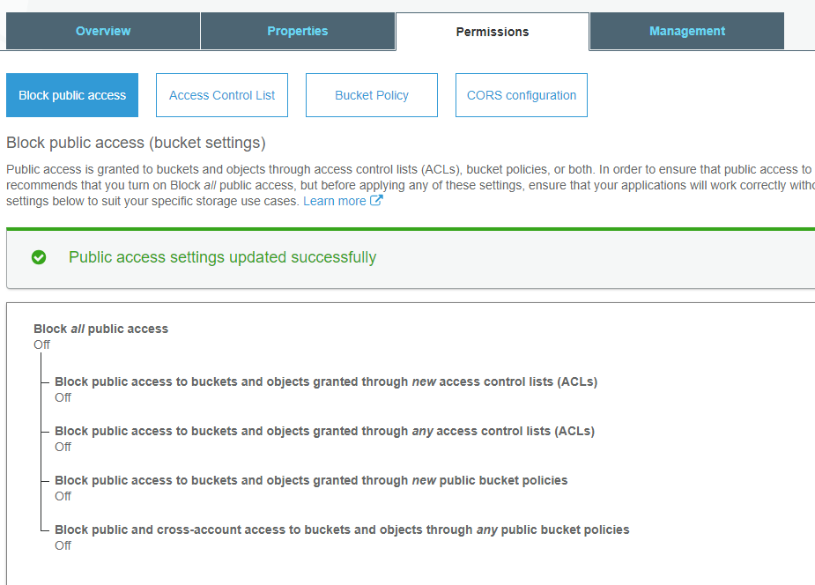

Once Public access is enabled upload the content need to be distributed in S3.Provide Public access to server and check the output of file.

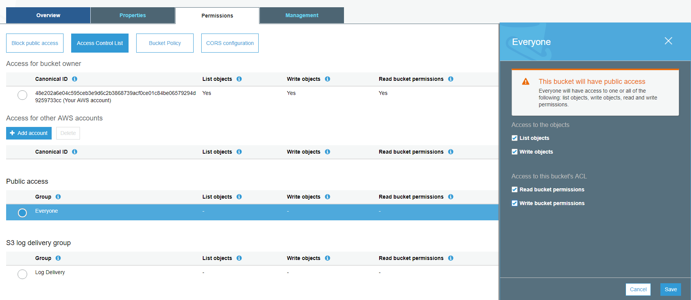

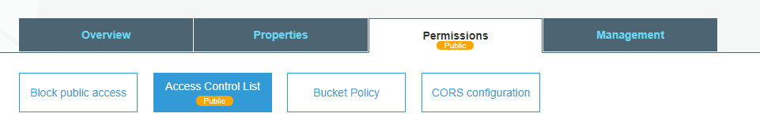

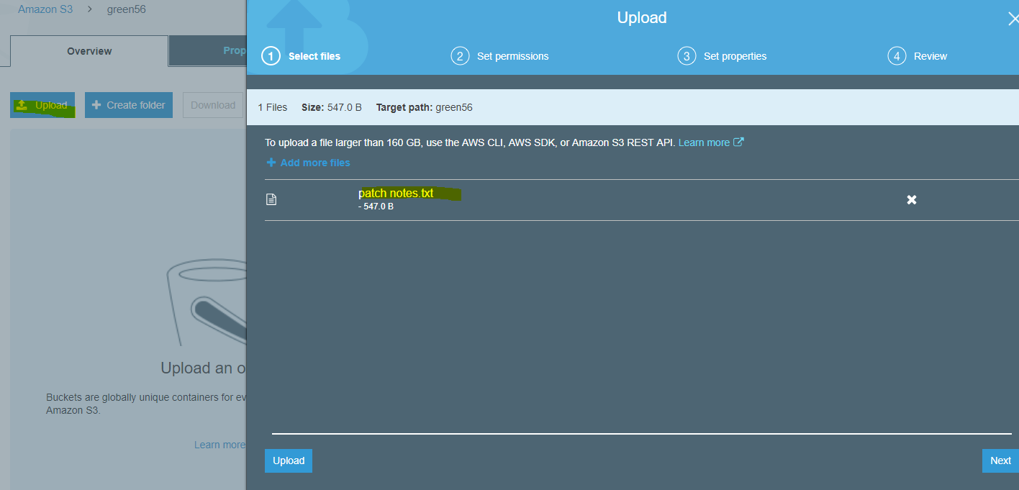

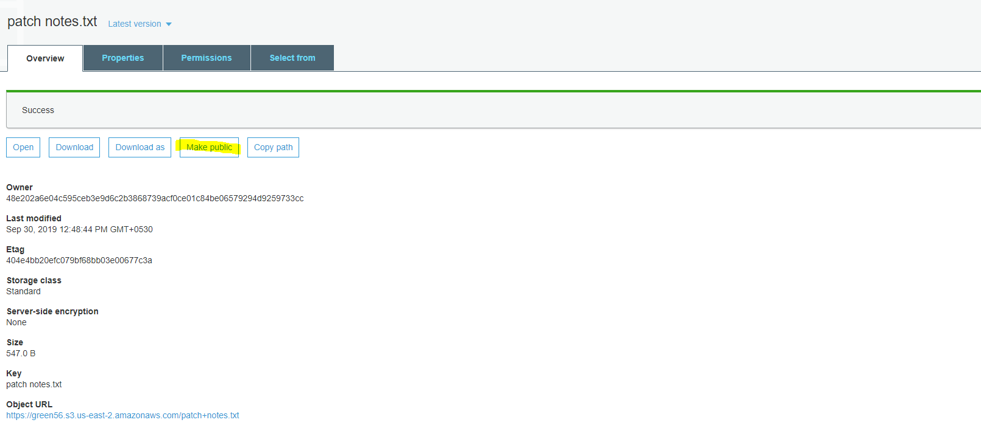

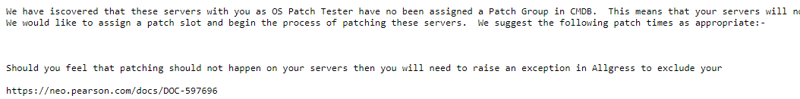

Click on create Distribution and select Web type distribution.

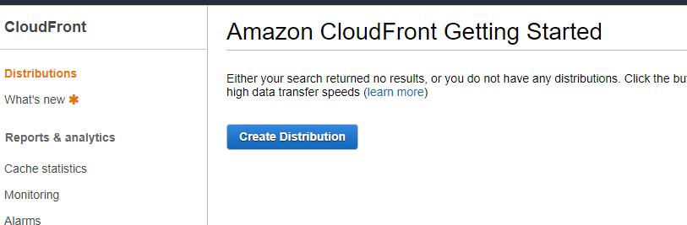

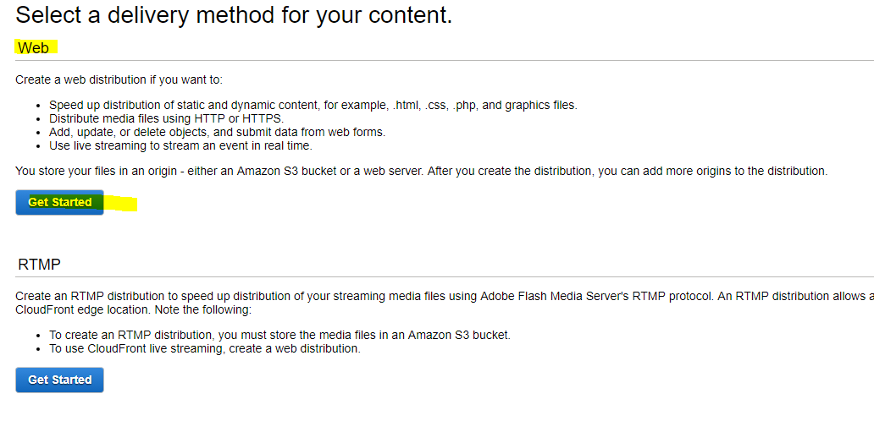

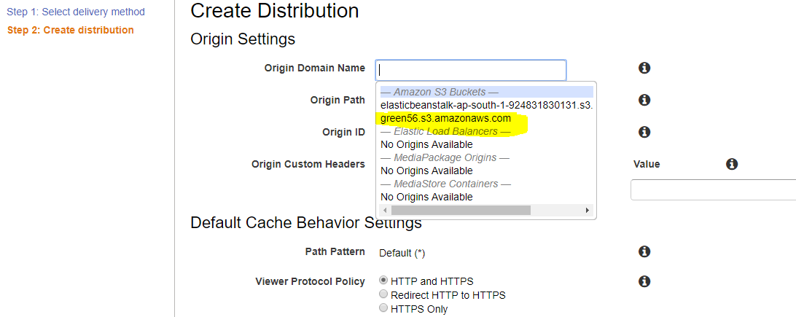

Select the Origin S3 Bucket and enable Bucket access YES and Bucket Policy also Yes.

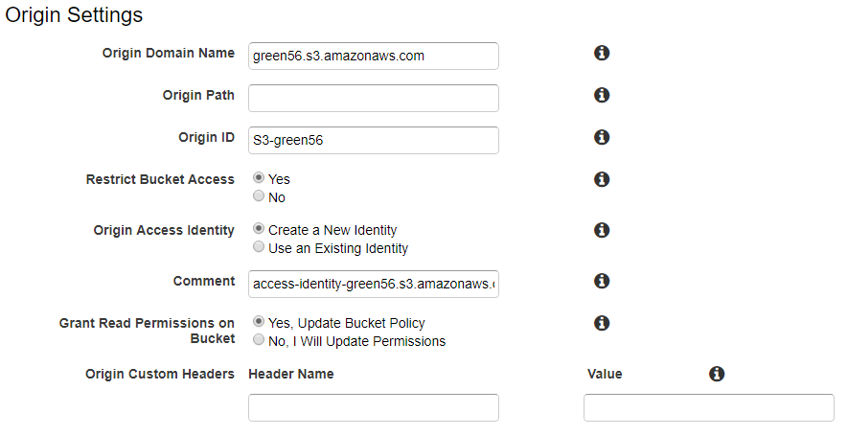

Click on HTTP-HTTPS option and then its connectivity component.

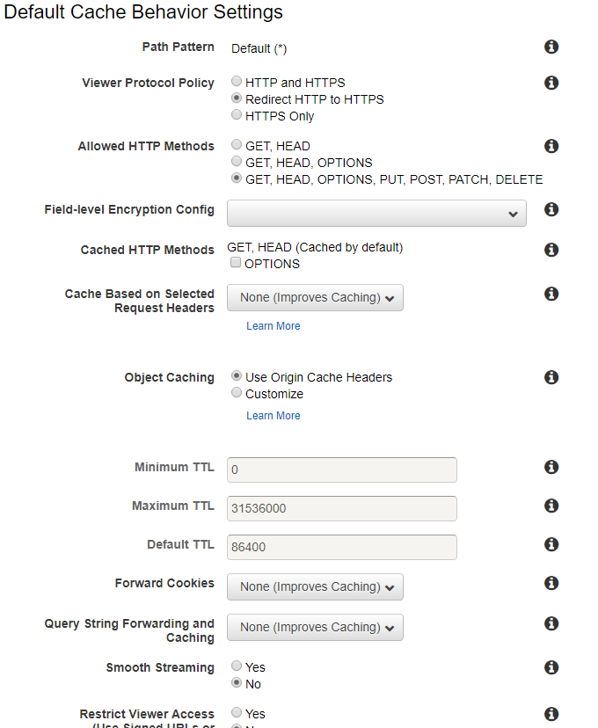

Check whether you have selected the right url path and Distribution state is enabled.

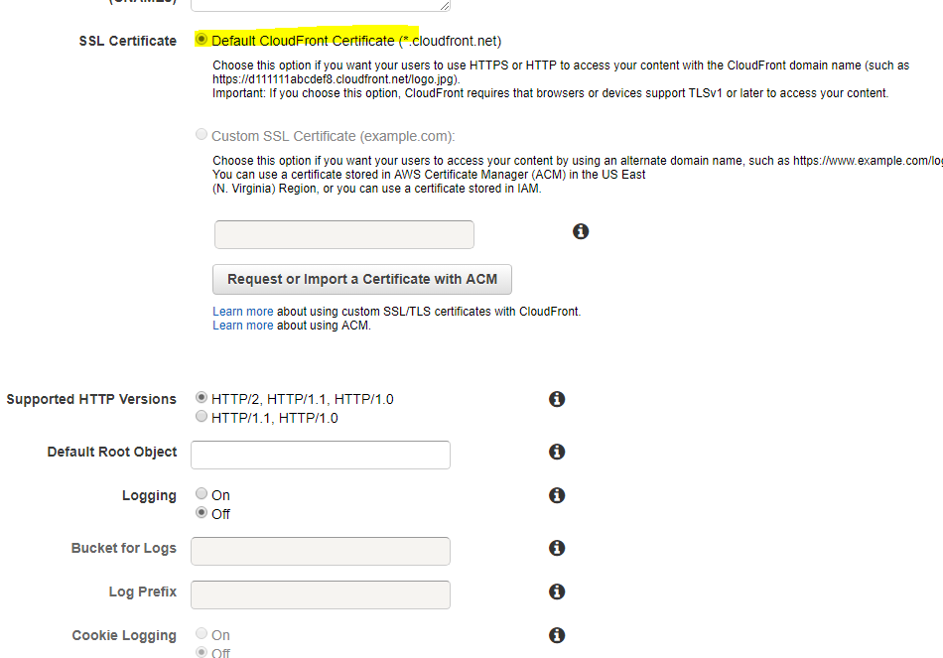

Once server become available take the Domain name along with origin path to check whether the content is distributed or not.

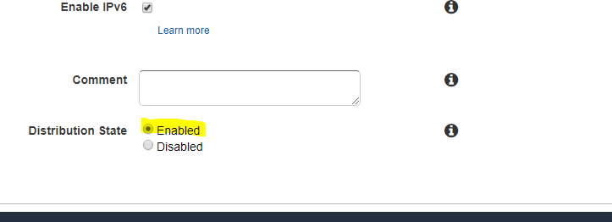

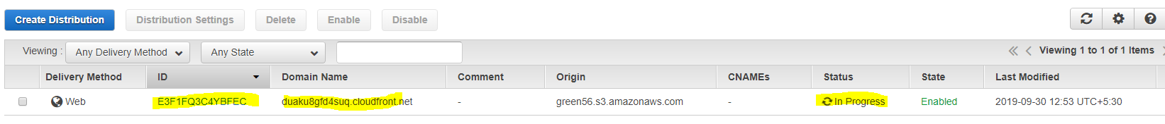

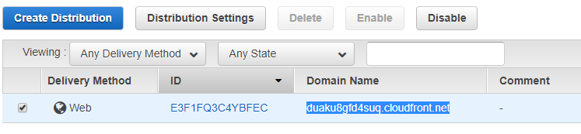

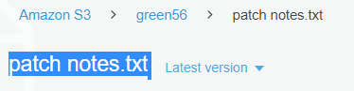



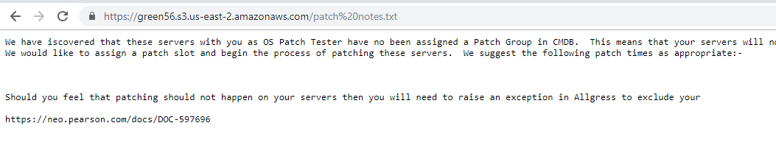

Once all done disable the CDN and after 5-10 min we can go ahead and delete the CDN compontent.

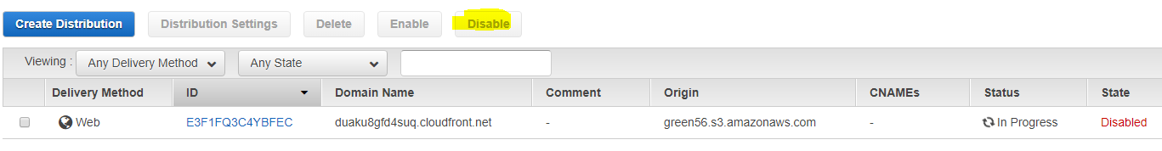

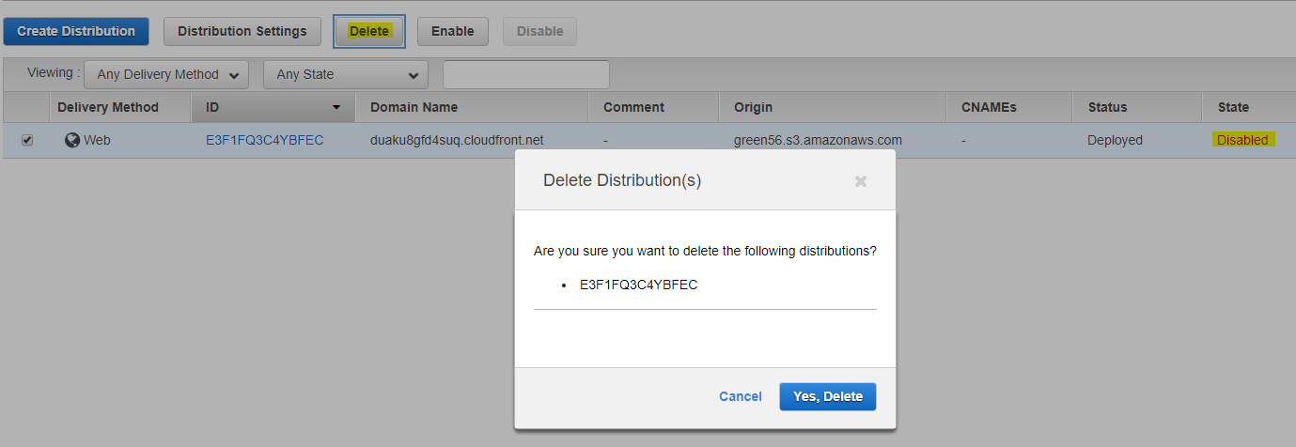

**CLOUDFORMATION:**

**Scenrio 1 :**

Once you opened the CF console switch to previous concole for better experience.

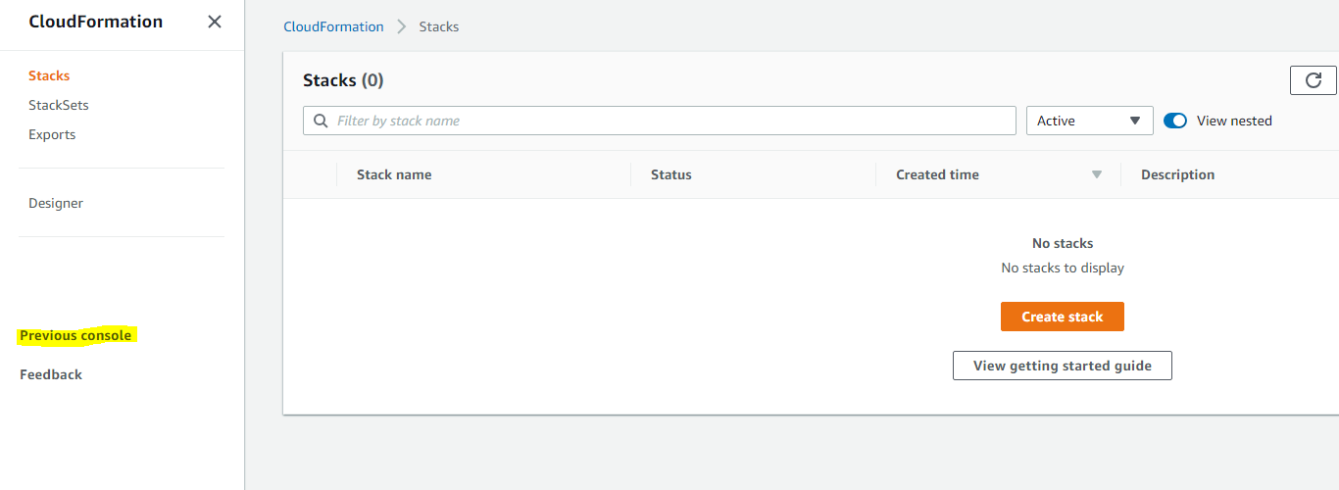

Then select the required component whch you need to need perform automation using CF templates.For sample Here we take S3 Bucket to create the Bucket automatically where JSON script is written at bottom.

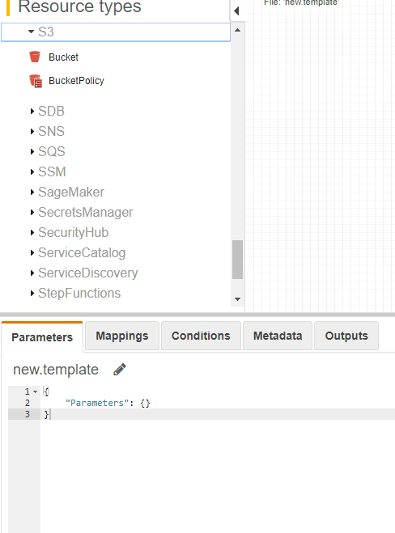

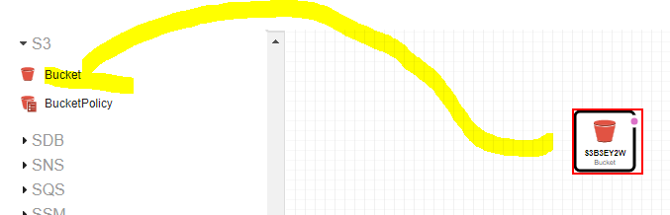

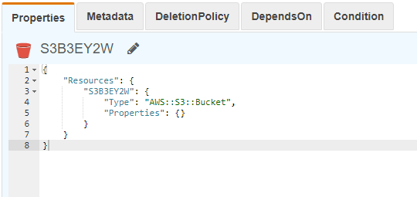

Then click on create stack and provide the name to stack.

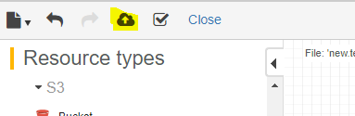

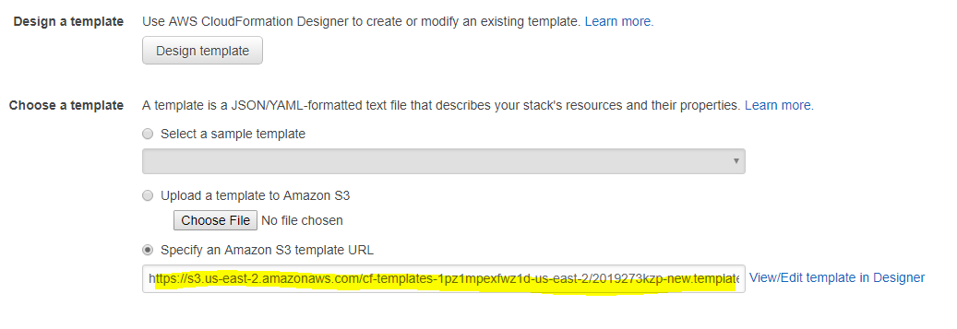

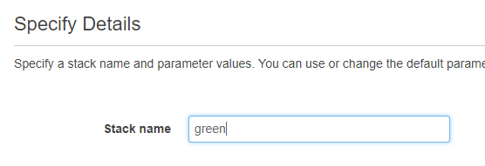

Then click on next tab and proceed further and complete the CF creation.



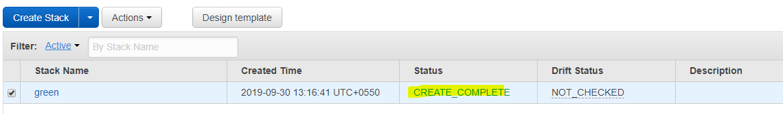

Verify whether S3 bucket is launched along with CF templates.

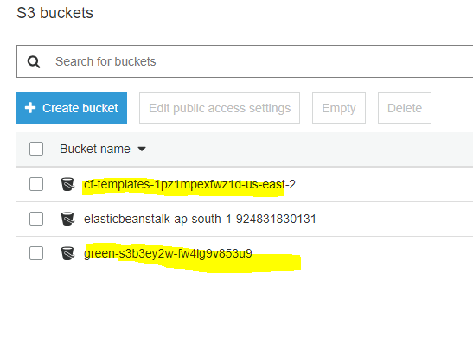

**Scenerio 2 :**

Click on create stack and select the required template(Lampstack) which you need to automate from dashboard and proceed further.

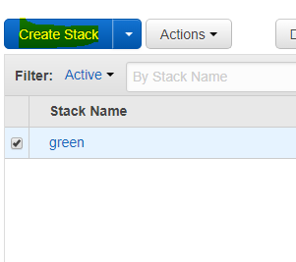

Provide the stack and databases details along with password and type of EC2 instance with Key to create the stack.

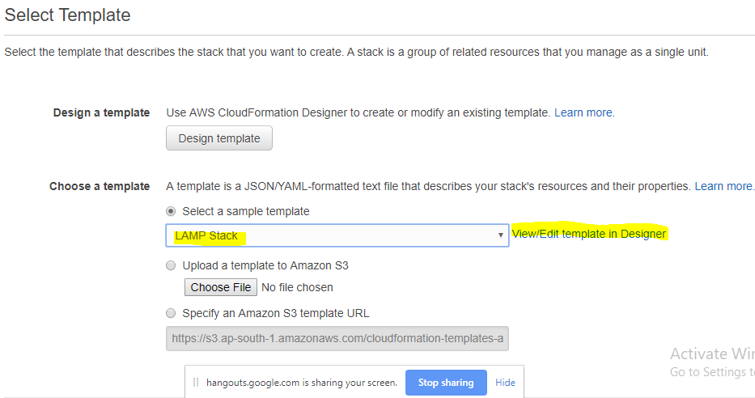

Then click on create stack.

Click on stack which you newly created to see the log where you can ensure that you have launched one EC2 instance along with database embedded on it.

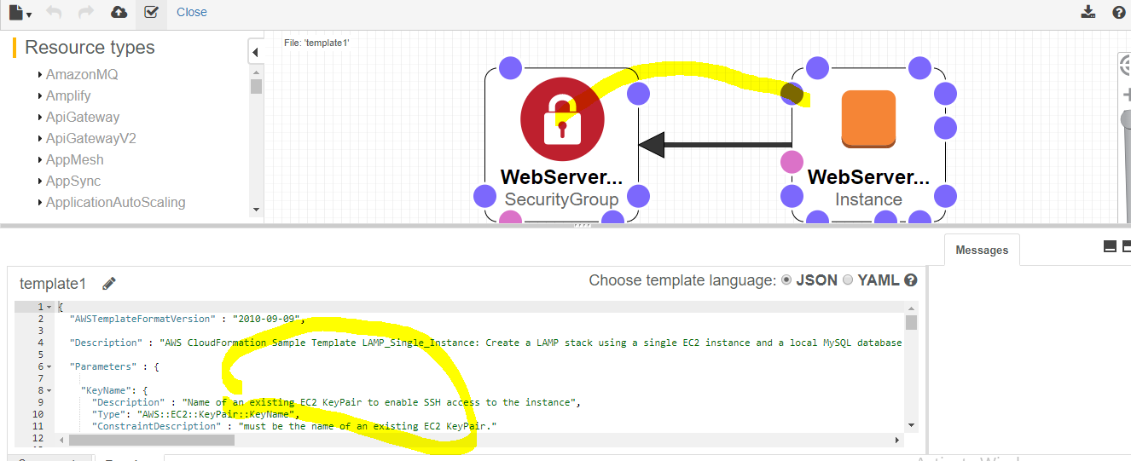

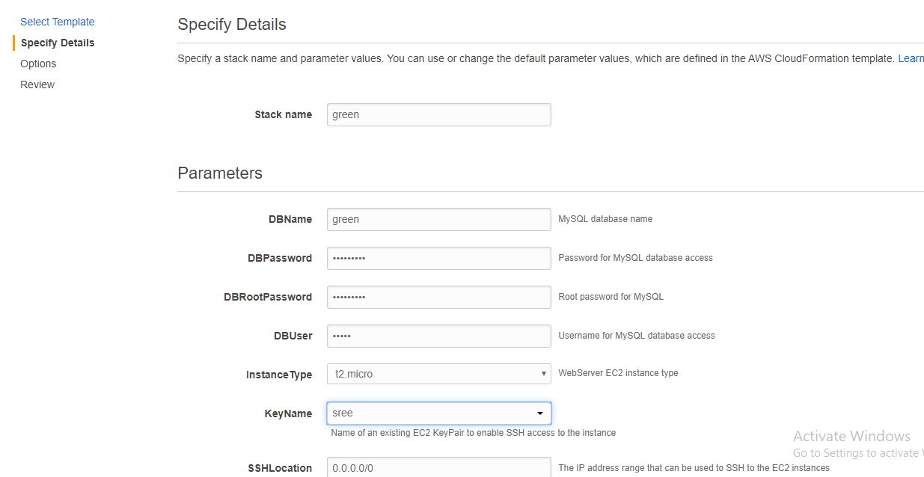

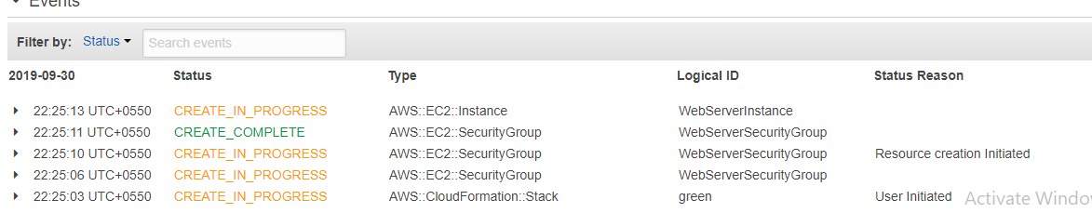

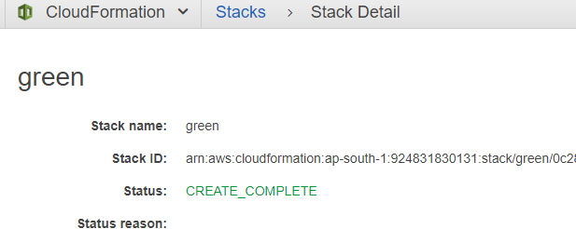

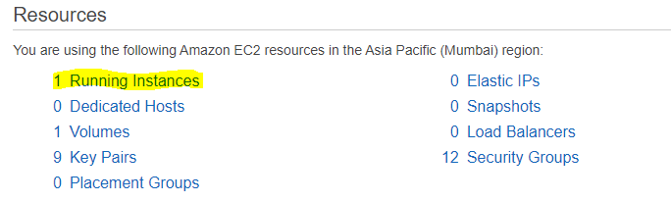

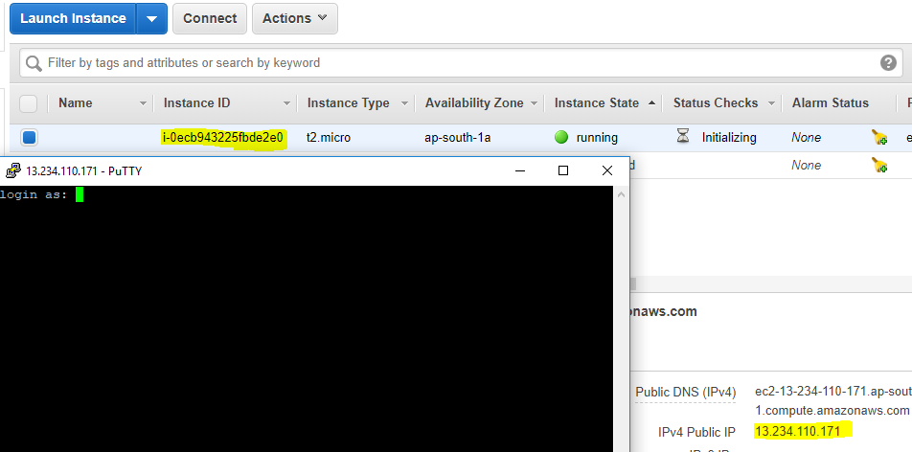

Try to connect the instance with its ip once instance opens just give the command **as "mysql -h localhost -P 3306 -u username -p"**

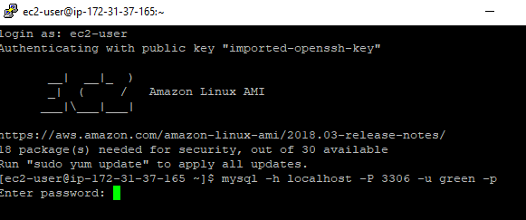

Then enter the password which you have created during database creation

Provide show databases; to verify whether the database which we created is present or not.

